Change the column format for the Timestamp column to, “m/d/yyyy h:mm:ss.0”, like this:

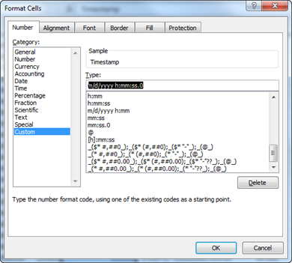

That will change the display from this:

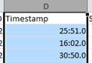

To this:

